**Class Activity: Room Database**

1. Create a new project with the following configuration,
   1. Empty Activity
   2. Language: Java
   3. Minimum API level: API 21: Android 5.0 (Lollipop)
2. Add the Gradle dependencies.
   1. Open build.gradle file for your module from here.

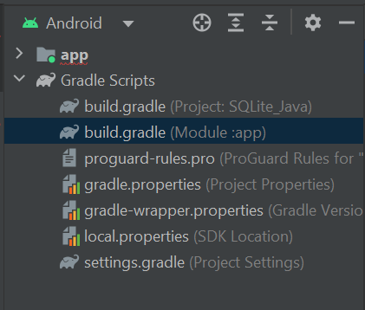

* 1. Add the following dependencies.

| implementation "androidx.room:room-runtime:2.6.0"  annotationProcessor "androidx.room:room-compiler:2.6.0" |
| --- |

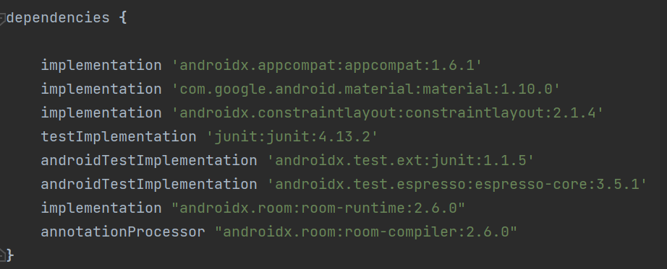

1. Create the layout of your main activity according to the figure shown below.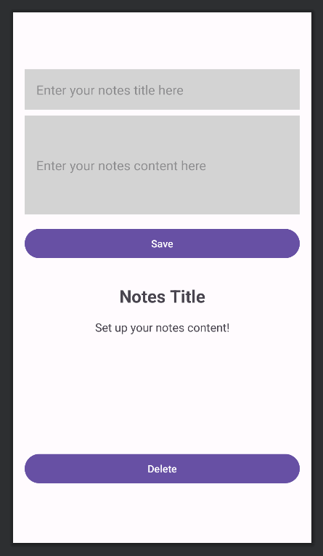

Create 2 EditText here to allow user input for notes title and notes content. The background colour used here is #D3D3D3. Remember to use the “textMultiLine” input type for notes content EditText.

Create a button here to save the user input into Room database.

Create 2 TextView here to display the notes title and notes content. The default text to display for title is “Notes Title” and “Set up your notes content!” for content.

Create a button here to delete the notes from Room database.

1. Create Data Entity for Note class based on the class diagram below. Create Note class in a separate file called *Note.java*.

| Note |
| --- |
| - id: int  - title: String  - content: String |
| + Note()  + Note(id: int, title: String, content: String)  + setId(id: int)  + getId(): int  + setTitle(title: String)  + getTitle(): String  + setContent(content: String)  + getContent(): String |

1. Create Data Access Objects (DAOs) for Note class, called *NoteDao.java*.

Inside NoteDao interface, create void insert(Note note), void delete(Note note) and Note getNoteById(int id). Use the @Insert annotation for insert(Note note), @Delete annotation for delete(Note note) and @Query annotation for getNoteById(int id) where you will need to specify the SQL statement you use for this function.

When you use the @Insert and @Delete annotation, only data entities that are defined can be used as the parameter of these 2 functions.

1. Create a database called NoteDatabase by defining an abstract class that extends RoomDatabase. This class will list the entities contained in the database, and the DAOs which access them. In this activity, you will list the Note entity and NoteDao.
2. In the *MainActivity.java*, declare variables to link specific UI elements from the Android layout file. Create an instance of the NoteDatabase using Room databaseBuilder.
3. In the *MainActivity.java*, define an ‘ExecutorService’ object to execute the database operations as following.

| ExecutorService executorService = Executors.newSingleThreadExecutor(); |
| --- |

Using an ‘ExecutorService’ in combination with Room database for executing database operations is a common practice in Android App development as it ensures good performance and responsiveness in your app. Performing database operations on the main thread can block the UI, leading to unresponsive or sluggish user experiences. By using ‘ExecutorService’, you can offload database operations to background threads, ensuring that the main thread remains responsive.

1. In the *MainActivity.java*, create 3 classes, InsertNoteRunnable, DeleteNoteRunnable, and DisplayNoteRunnable that implements Java Runnable interface. You need to override and provide implementation for the run() method of Runnable.

For the InsertNoteRunnable class, it should take a Note object as the parameter. Inside the run() method, insert the Note object into the Room database.

For DeleteNoteRunnable class, it should take in an ‘int’ parameter representing a note’s id. Inside the run() method, set the id = 1 and retrieve this note from the database and then delete it.

For DisplayNoteRunnable class, it should take in an ‘int’ parameter representing a notes’s id. Inside the run() method, set the id = 1 and retrieve this note from the database. If the note exists, set the 2 TextViews with this note’s title and content. If the note does note exists, set the default values as the one in Step 3 in the 2 TextViews.

For the simplicity of this activity, the id of all the Note objects involved is 1 when performing the database operations. Add the following to the @Insert annotation in *NoteDao.java* to solve the primary key conflict.

| @Insert (onConflict = OnConflictStrategy.REPLACE)  void insert(Note note); |
| --- |

If you attempt to insert a new record into the database with a primary key that already exists, Room will replace the existing record with the new one.

1. After implementing the 3 classes, you can use the executorService as the following to perform the database operations.

| executorService.execute(new InsertNoteRunnable(note)); |
| --- |

You need to provide a Runnable or Callable object to the ‘ExecutorService’ to specify the task that should be executed on a background thread. A Runnable or Callable object is the required parameter type for execute().

1. In the *MainActivity.java*, create setOnClickListener for the save and delete buttons. For the save button, it should store the title and content inputted by the user as a Note object into the database. For the delete button, it should delete the Note object from the database.
2. For debugging, you can use Database Inspector to debug your database.
   1. Run your app on an emulator.
   2. From the menu bar, select View > Tool Windows > App Inspection.
   3. Select the Database Inspector tab.

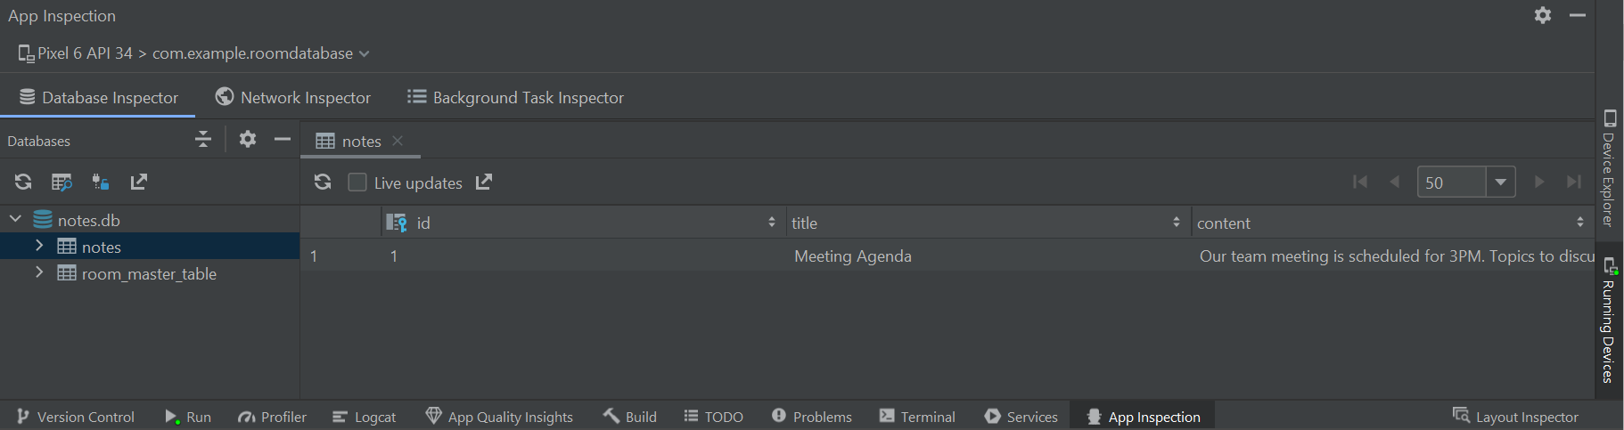

1. **Expected Output**

